SOUTHERN UNIVERSITY COLLEGE

ACADEMIC YEAR 2020

SEPTEMBER EXAMINATION

**BTIS3063 DIGITAL MEDIA MARKETING**

DATE: TIME:

BACHELOR IN SOFTWARE ENGINEERING (HONOURS)

YEAR ONE

YEAR TWO

YEAR THREE

**Instruction to Candidates:**

Answer **ALL** questions. All questions carry equal marks.

Answer ALL questions in Word format.

Save it as portal document format (PDF).

Name it as Final__BTIS3063_2020B_<studentID>. For instance: *Final_BTIS3063_2020B_B111111C*

Submit through designated Microsoft Teams’ assignment section.

Submit a back-up copy with code through designed OneDrive shared file.

Please read the following case study to answer all questions.

Case Study 1: Minister says Malaysian varsities to fully reopen by Oct, international students can return subject to Covid-19 tests.

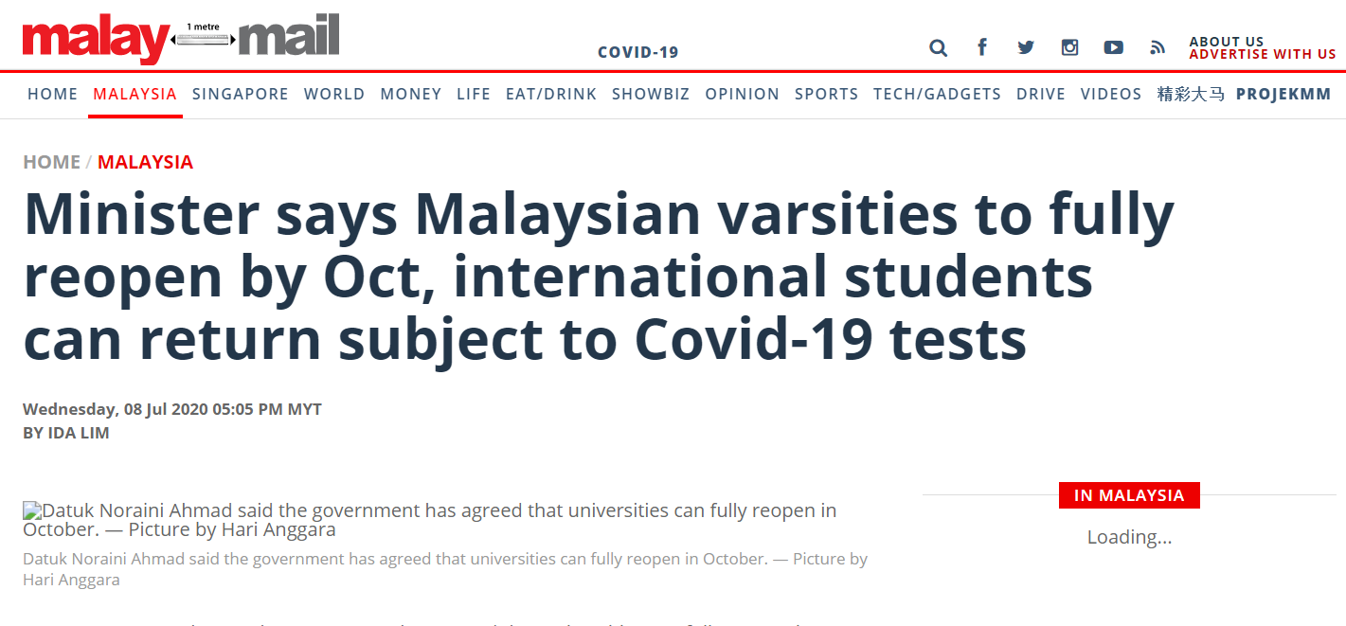

Source adopted from <https://www.malaymail.com/news/malaysia/2020/07/08/minister-says-malaysian-varsities-to-fully-reopen-by-oct-international-stud/1882659>

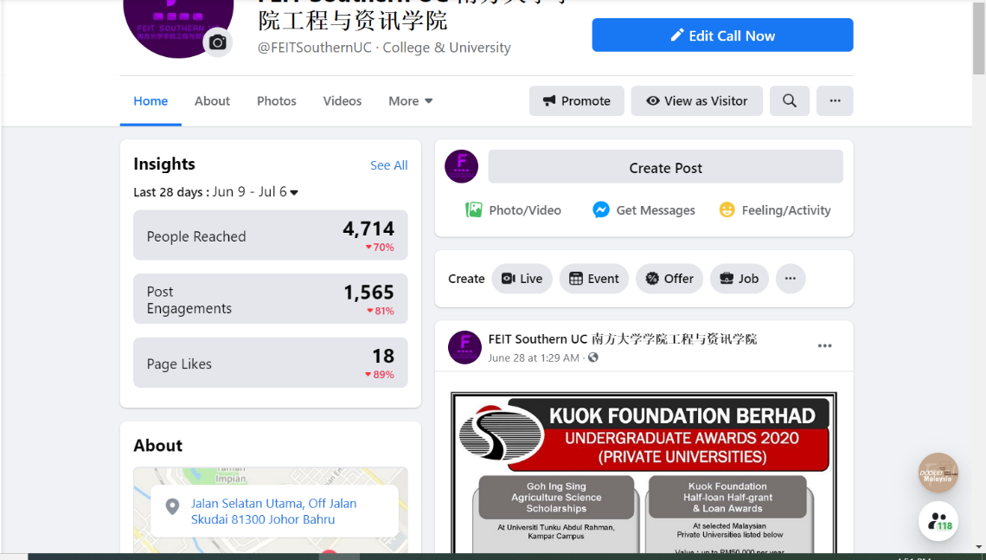

Figure 1: FEIT Southern UC Facebook page

Image credit: <https://www.facebook.com/FEITSouthernUC>

New semester commencement date: 12 October 2020

Recruit new students’ duration: 1 August 2020 – 25 October 2020

Campaign budget: RM1, 000

Target goal: To recruit the number of students according to programme.

|  |  |
| --- | --- |
| **Programme** | **Target number of students** |
| Diploma in Information Technology | 10 |
| Diploma in Computer Science | 10 |
| Bachelor in Software Engineering | 10 |

Table 1: target number of students per programme

1. Assume that you are hired as social media consultant for Faculty of Engineering and Information Technology (FEIT). You are requested to design a digital media campaign to recruit new students for October intake. Prepare a situation analysis for the assigned campaign. The situation analysis should include:
2. Customers

* Who

1. Newly graduated middle school students.
2. STPM graduated students
3. Youth under 25.
4. Parent

* Why

1. A digital marketing campaign is an online strategy with the goal of promoting a business' product or service by increasing engagement, traffic and conversions.
2. Nowadays, many young people are using social media. They can use social media to find the programme he wants to study.
3. Let young people who are interested in studying can get a general understanding of the content of our faculty.

* How

1. Will put some posts or videos on Facebook or Instagram Platform.
2. Competitors

* 
* https://www.newera.edu.my/index_cn.php
* 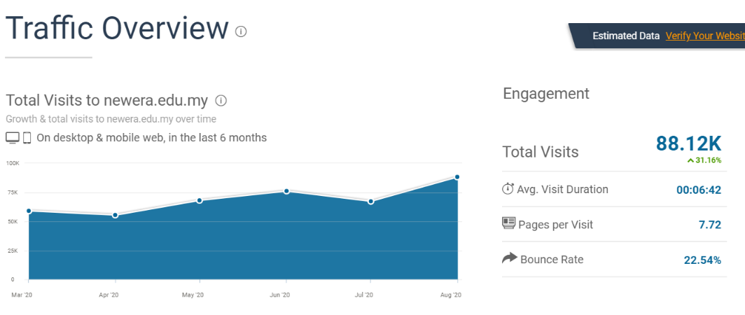
* The total number of visits is about 88K in the past 6 months
* The average visit time is about 6.42 minutes.
* 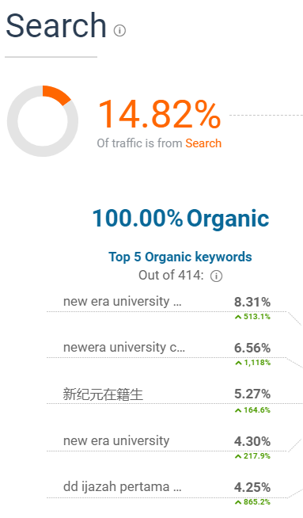
* The most searched keyword is “new era university”, which is as high as 8.31%.
* 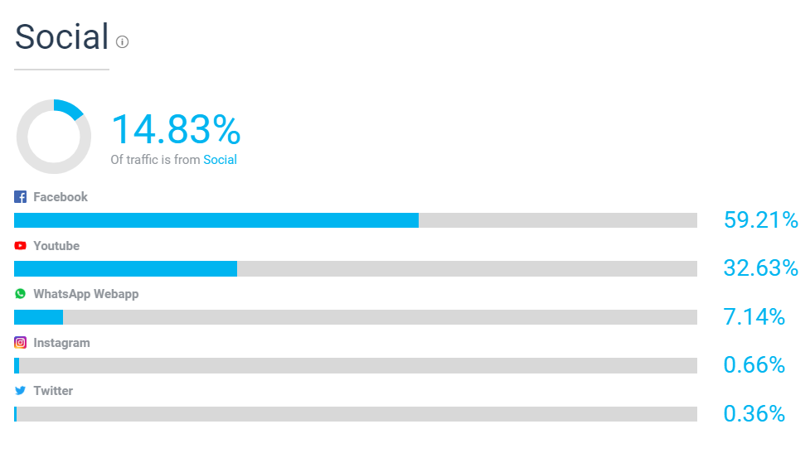
* The highest of social traffic is Facebook, up to 59.21%.

1. Competencies (performance analysis)

* At the beginning, I will put some posts about our faculty.
* 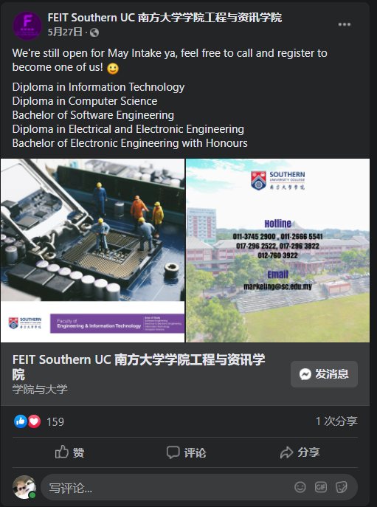
* This is a post about faculty. There are many people who liked the post, all of which have more than 100 likes.
* We will distribute the important content of our faculty into a post. For example, what programs does our faculty have and what each program focuses on.
* After the first month, we will analyse the data about the coverage of posts and reach of our post.
* We will learn how many students have signed up for our courses so that I can re-evaluate the target audience.
* After that, I may post some videos, because the effect of photos alone may not be better than video.
* 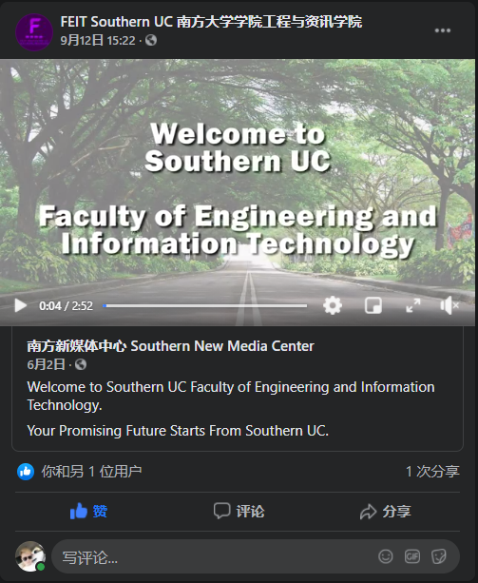
* This video introduces some class process, students' works and so on. You can let people who are interested in that can get a good understanding.
* We publish about one to two posts or videos on our Facebook page every two to three weeks.
* In addition, we also do interviews, speaker events and etc.

1. SWOT analysis

|  |  |
| --- | --- |
| **Strengths**   * Strong variety of value-adding Facebook posts * Visually lead Facebook content achieving good reach * Increasing web traffic | **Weaknesses**   * No other social media platforms such as Youtube or Twitter are used for promote * Overly self-promotional content * Poor web experience |
| **Opportunities**   * No competitors on Twitter or Youtube. * Potential to dominate the space. * Refine customer contact strategy across customer lifecycle or commitment segmentation (Email, Linking) | **Threats**   * Main Competitor has massive offline presence * Less budget * Negative public perception * Potential to diffuse this to social media platforms. |

[Total: 25 marks]

1. Based on the situation analysis in **Q1**, propose a digital marketing strategy for the campaign based on TOPPP SITE. Your strategy plan should include:
2. Target markets

* Our market target is mainly high school graduates and STPM graduates.
* Some related content about our faculty information, lesson video, and students' works may be released. These can easily attract people who are interested in studying.
* We can also upload some content about the price, after all, people are still very realistic.

1. Positioning

* What we mainly publish is related to IT, especially programming, coding and the like, so that the target will not feel that we are just study textbooks only.
* We will repeatedly upload posts every other month to remind us of recruit new students’ duration and enrollment time.
* Let target to understand, the following:

1. the programmes in our faculty.
2. the course of programmes.
3. Faculty Information
4. Programme fee
5. Integration

* We will provide Request form for visitors to collect how many people are interested in our faculty.
* Some questionnaires will be conducted to collect data. The questions are:

1. What interested are they?
2. What programmes are they most interested in?
3. What target need to understands?

* Required budget
* We will use the data we have integrated and analysed to determine the content of our subsequent posts.

1. Tactical tools

* We will use the Facebook and Instagram platforms to post our image or video about the campaign.
* We will also use the analysis tools on the social media platform to help us analyse those posts and time slots that are viewed by more people.
* We also use "similarweb" to analyse our website. We can know what the visitor came from and on which page the visitor stays longer. Using this data, we will add adjustments to the most visited pages.
* Maybe using the “Canva” to develop our post.

1. Engagement

* During the open day, some small challenges, small competitions or exhibitions of students' works can be held, so that visitors can know our teaching content and students' works.
* Visitors can also consult us about courses through social media platforms.
* Some school lectures can be held, so that interested people can come and participate.
* Get target to participate.

[Total: 25 marks]

1. Refer to your analysis from previous questions, complete the following tasks. All images, audio, video or multimedia resources used in this question must be royalty free.

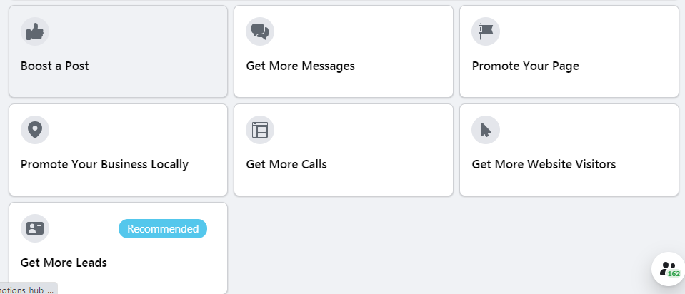

Figure 2: Type of advertisement for Facebook Page

1. Design a Facebook cover for this campaign. (5 marks)



1. Design an Instagram post for this campaign. (5 marks)

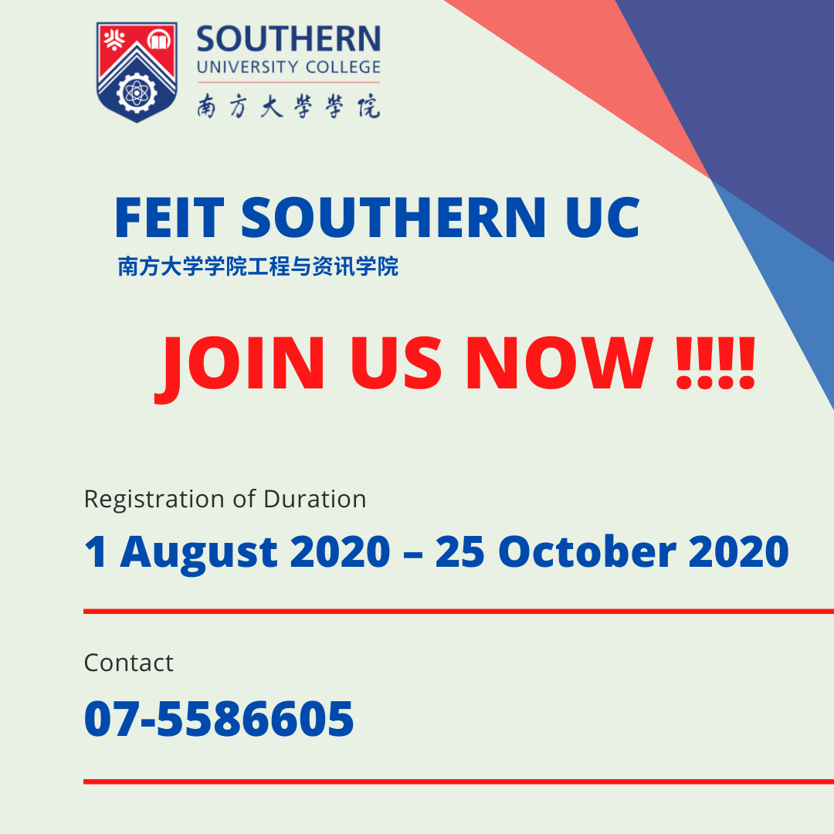

1. Prepare a Facebook advertisement post with image or video for this campaign.

(10 marks)

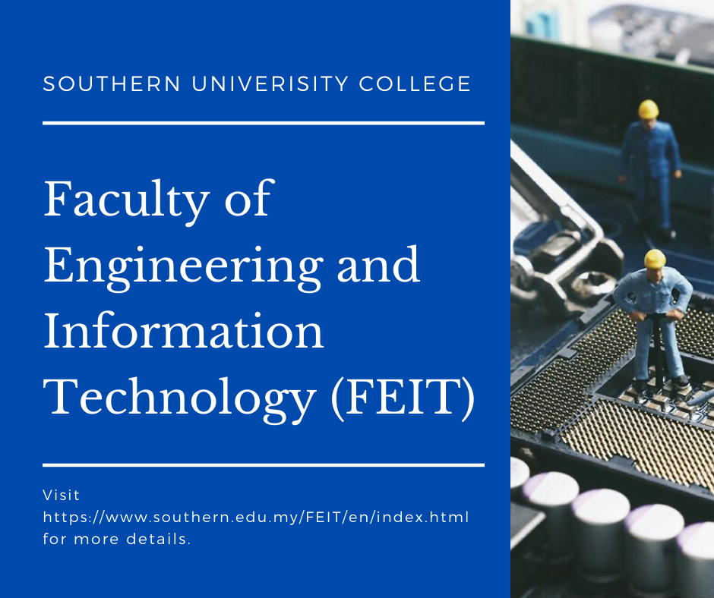

Figure 1

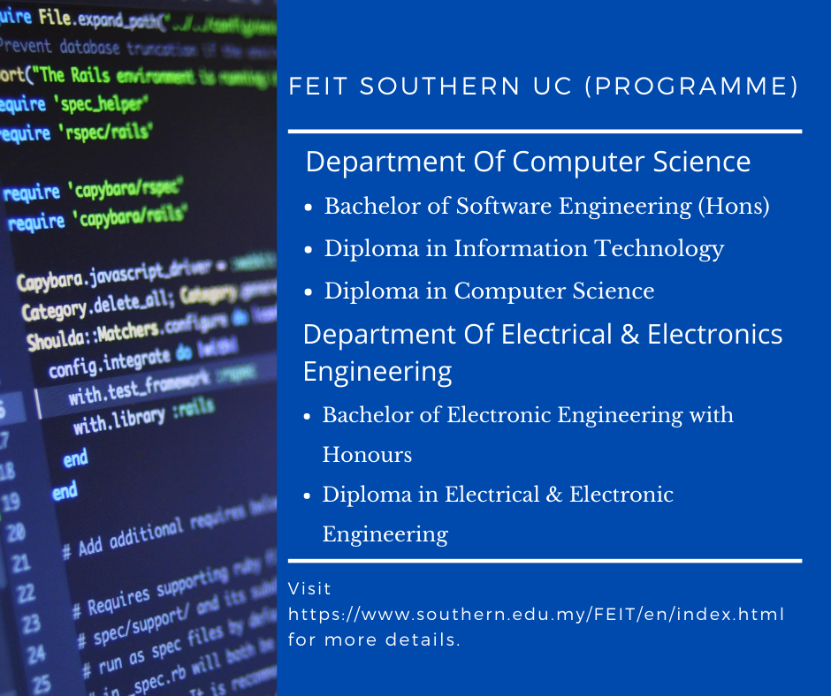

Figure 2

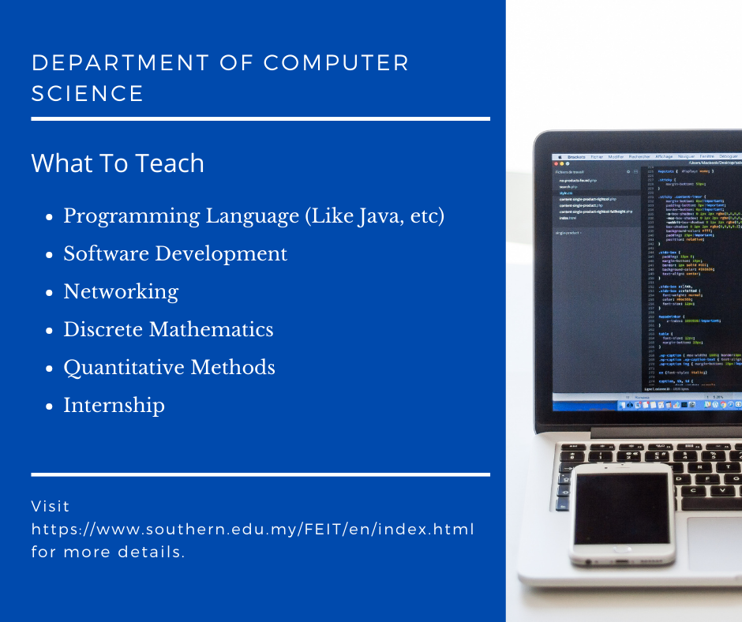

Figure 3

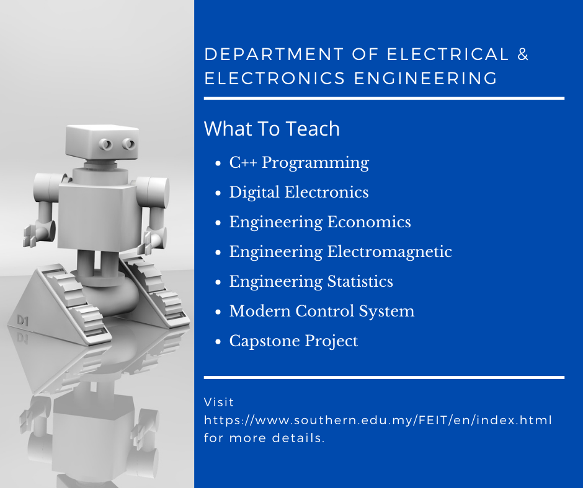

Figure 4

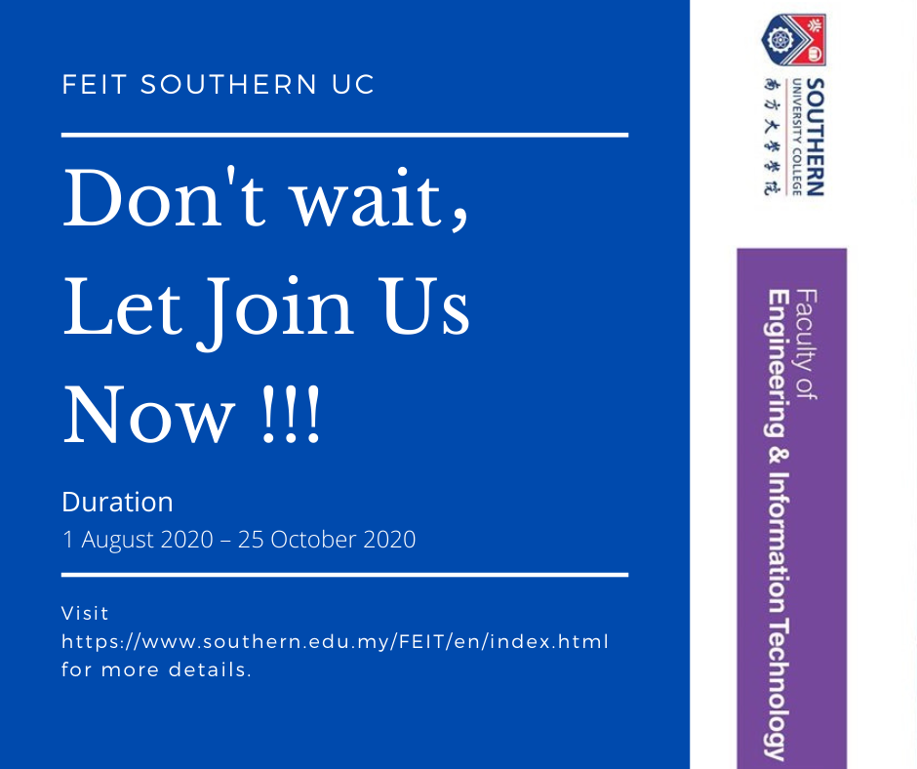

Figure 5

1. Prepare a budget plan for this campaign. (5 marks)

|  |  |
| --- | --- |
| Description | Budget |
| Staff Salary | RM300 |
| localized digital ads in Facebook (1 weeks) | RM200 |
| Website Update | RM375 |
| Office spends (Internet, Electricity, etc) | RM125 |
| Total | Rm950 |

[Total: 25 marks]

1. Refer to your analysis and design from the previous questions, assume that you are given extra RM1, 000 for the campaign to redesign faculty landing page.

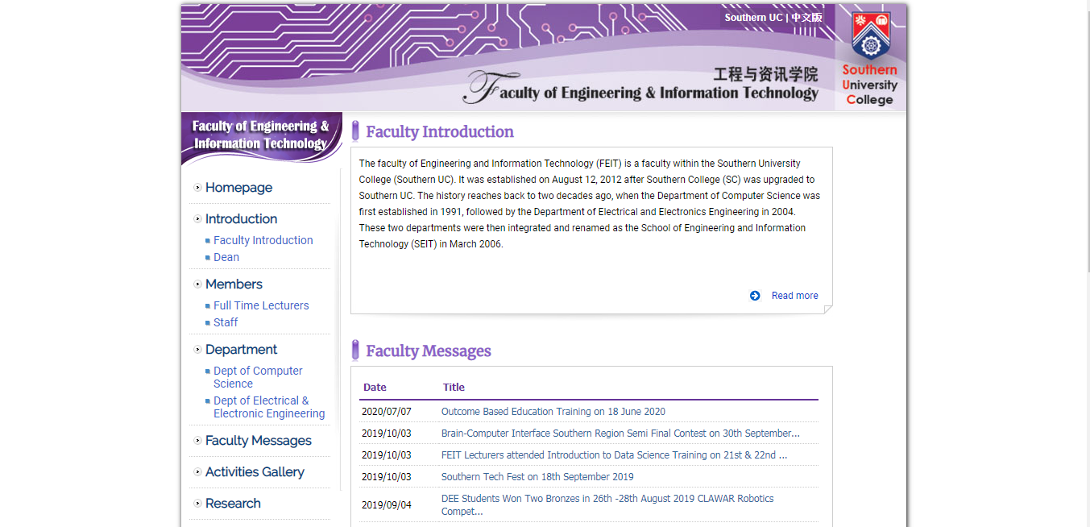

Figure 3: Faculty landing page <https://www.southern.edu.my/feit/en/>

Design and develop a landing page that include:

1. Request form for visitors’ contact detail such as name, contact number, residential area and year of graduate

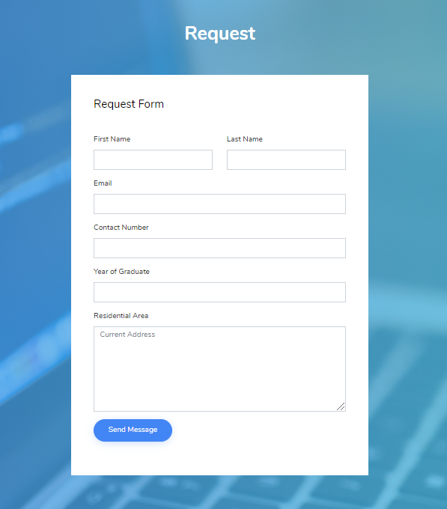

1. Programme information

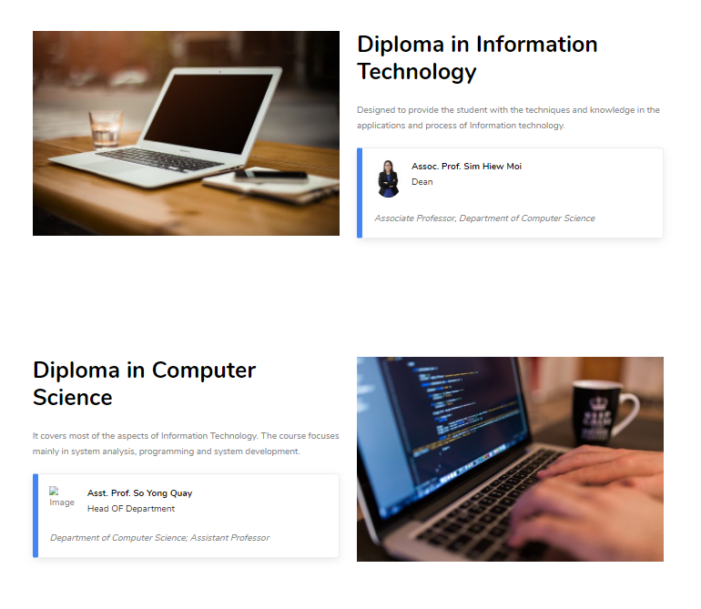

1. Relevant social media platform link



1. All images are royalty free

* All Image Download from “pixabay” without the lecturer Image.

1. Name and save the landing page in your student id. For example: *B11111C.html* or *B11111C.php*

https://github.com/B180279C/Final_BTIS3063

[Total: 25 marks]

________________________________________